The university of Azad Jammu & Kashmir, Muzaffarabad


Name | Adeela Bashir
Roll NO | 2024-SE-12
Course Title | Digital Image processing
Lab | 03
Submitted to | Sir Fahad

Department of Software Engineering

DIGITAL IMAGE PROCESSING LAB REPORT

Lab 03 Tasks: Basic Image Processing Techniques Using Python and OpenCV

1. Introduction

Digital Image Processing (DIP) is the process of performing operations on digital images to improve their quality, modify their appearance, or extract useful information. It involves applying mathematical and computational techniques to images using computers.

In this lab task, different image-processing techniques were implemented using Python, OpenCV, NumPy, and Matplotlib in a Jupyter Notebook. These techniques included brightness adjustment, contrast enhancement, image negative, gamma correction, histogram analysis, histogram equalization, CLAHE, and different thresholding methods.

The practical work began by loading and displaying the original color image. The image was then converted into grayscale and used as the input for the remaining image-processing operations.

2. Objectives

The main objectives of this laboratory task were:
- To load and display an original digital image.
- To convert a color image into grayscale.
- To understand basic image intensity transformations.
- To perform brightness and contrast adjustments.
- To generate the negative of an image.
- To apply gamma correction.
- To understand and analyze image histograms.
- To perform histogram equalization and CLAHE.
- To apply fixed, Otsu, and adaptive thresholding.
- To display and save the processed images.

3. Tools and Technologies Used

The following tools and libraries were used:

Python: The programming language used to perform image-processing operations.

Jupyter Notebook: The development environment used to write and execute Python code and display results.

- OpenCV: A computer vision library used to load, convert, process, and save images.
- NumPy: A Python library used for numerical calculations and array operations.
- Matplotlib: A visualization library used to display original and processed images.

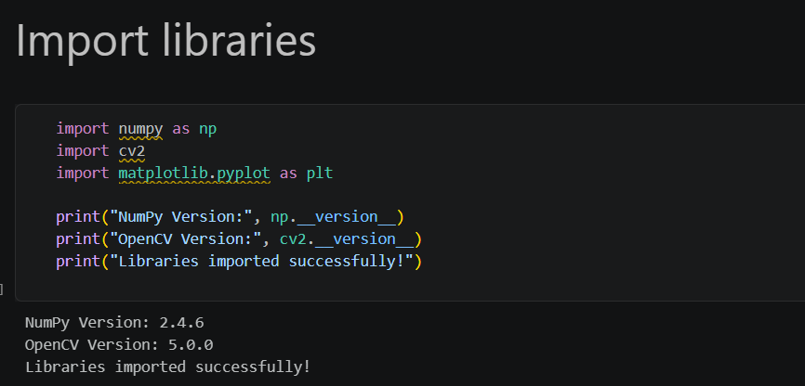

4. Loading and Displaying the Original Image

- The first step was to load the original color image into the Jupyter Notebook. The image was read from the computer using OpenCV.
- After loading, the original image was displayed using Matplotlib. Since OpenCV reads color images in BGR format while Matplotlib expects RGB format, the image color channels were converted before displaying it.
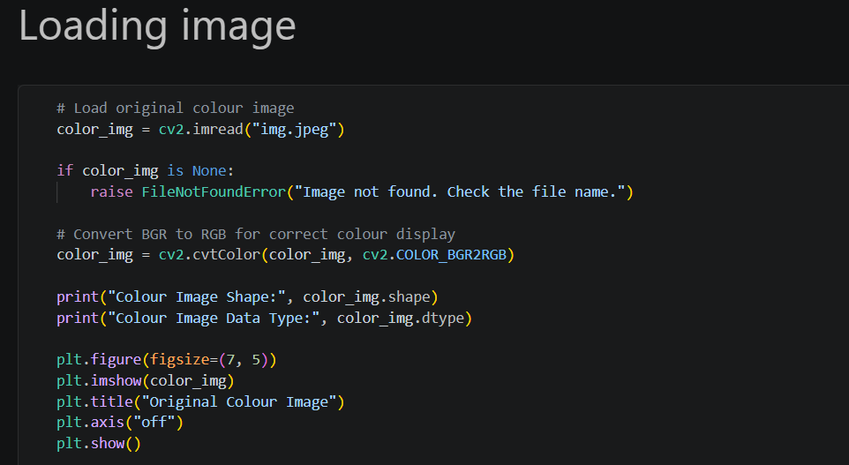

This step allowed us to view the original image before applying any processing techniques. It also provided a reference for comparing the results of the different operations.
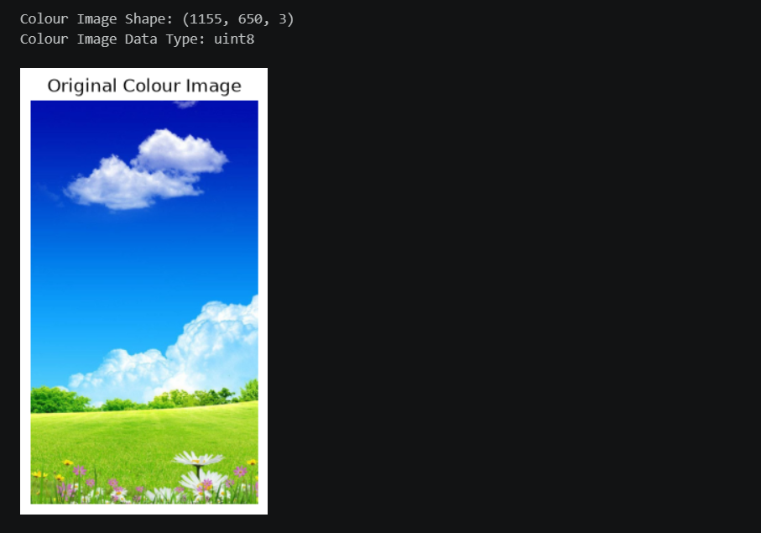

5. Conversion of Color Image into Grayscale

- After displaying the original color image, the next step was to convert it into grayscale.
- A grayscale image contains different shades of gray instead of separate red, green, and blue color channels. Each pixel represents an intensity value ranging from 0 to 255, where 0 represents black and 255 represents white.
- Grayscale conversion simplifies image processing because it reduces the colour information and allows operations to be performed on a single intensity channel.
- The converted grayscale image was displayed separately and used as the input image for the remaining practicals.

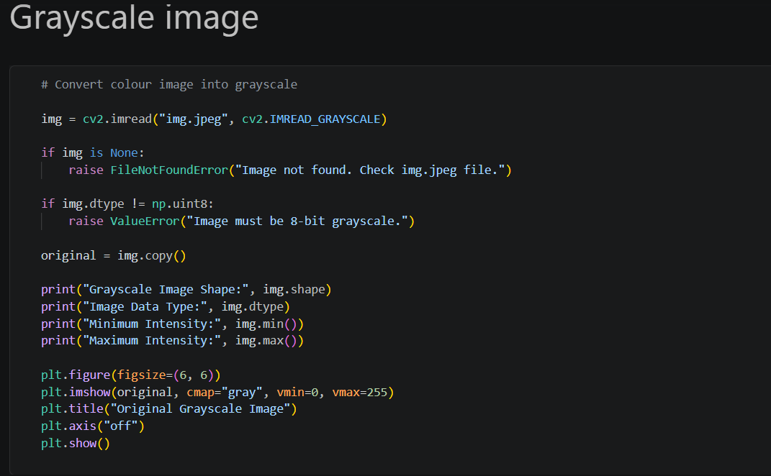
The grayscale image was also included in the final image-saving process.
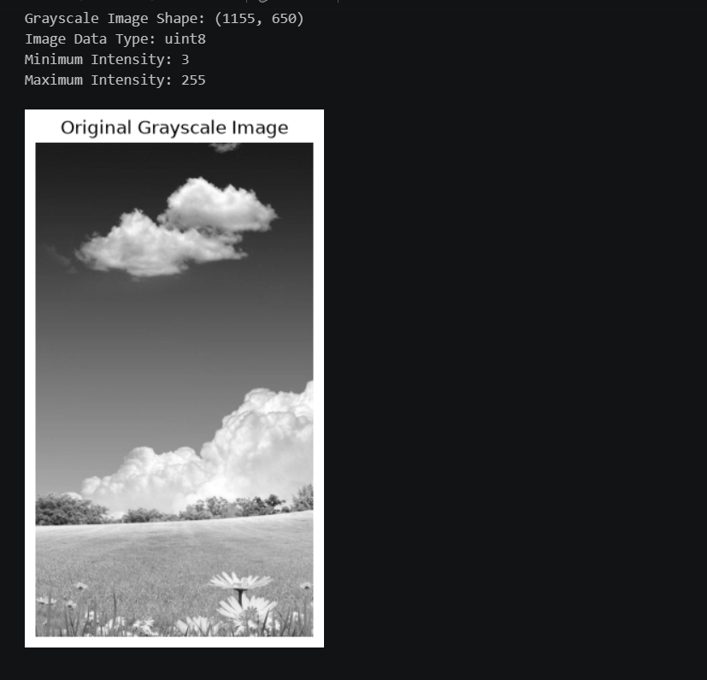

6. Practical 1: Brightness Adjustment

- Brightness adjustment is an image-processing technique used to increase or decrease the overall intensity of an image.
- In this practical, brightness was increased by adding a positive value to the pixel intensities. A separate operation decreased brightness by subtracting a value from the pixel intensities.
- When brightness was increased, the image became lighter. When brightness was decreased, the image became darker.
- Pixel intensity values were maintained within the valid range of 0 to 255. Values exceeding this range were limited to 255, while values below zero were limited to zero.
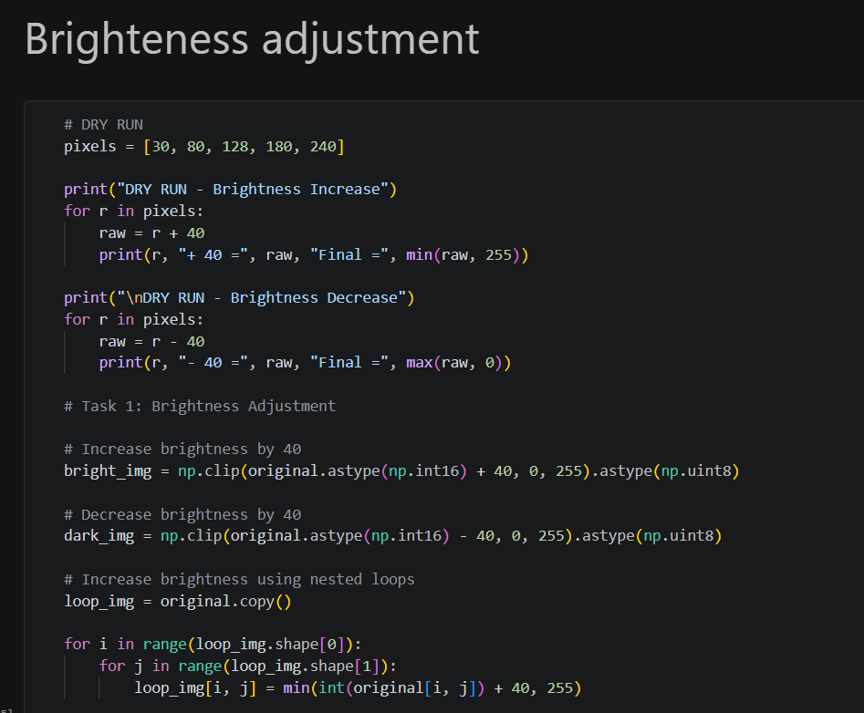
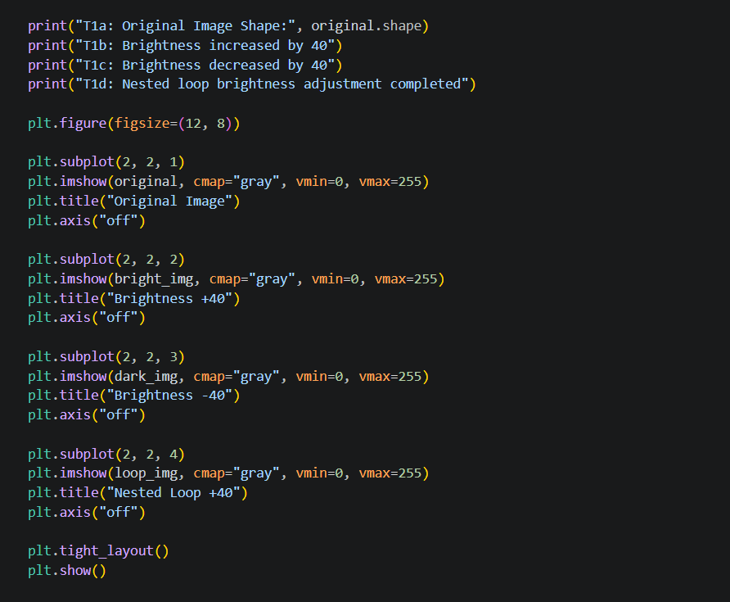
Result: Two processed images were obtained: one with increased brightness and another with decreased brightness.
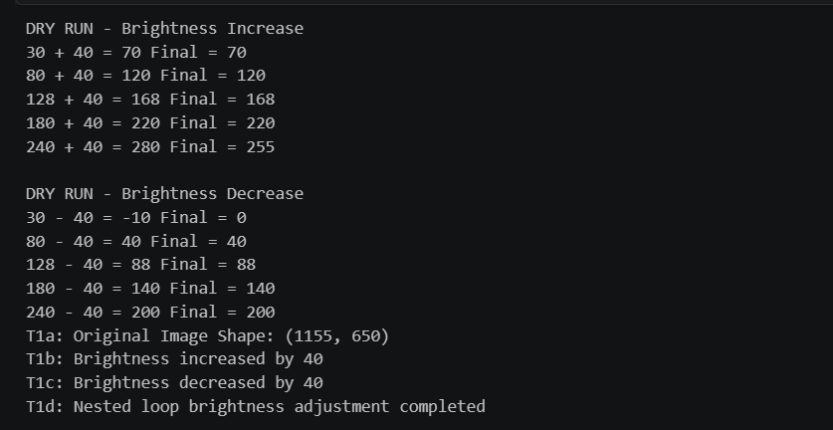
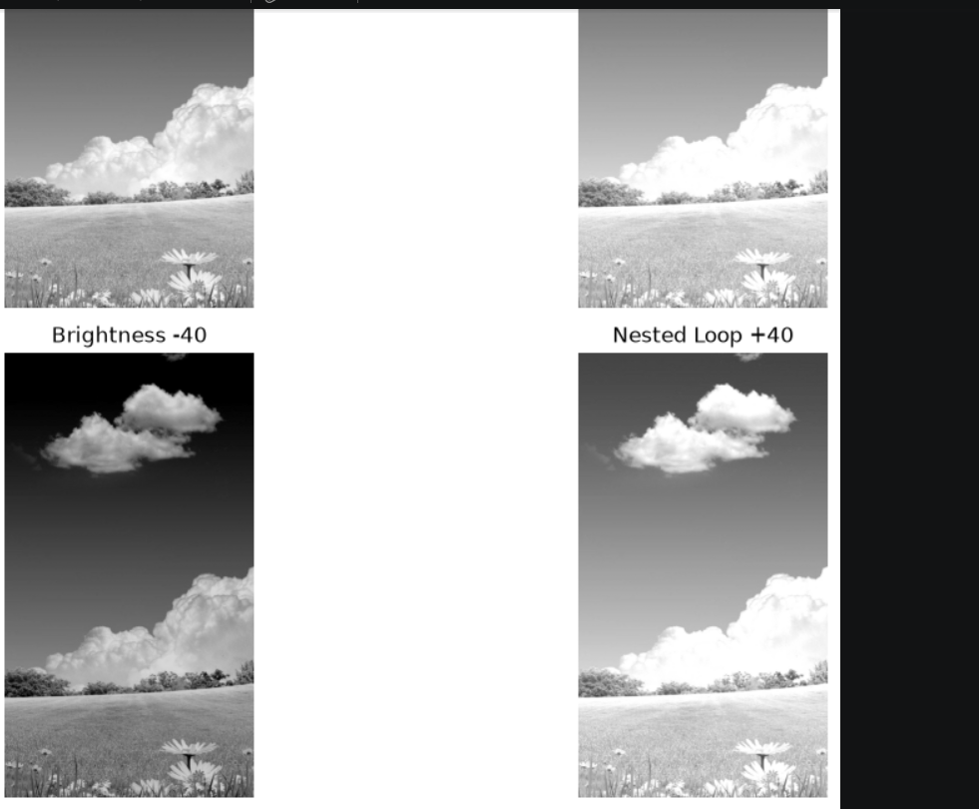

7. Practical 2: Linear Contrast Adjustment

- Contrast refers to the difference between the dark and bright regions of an image.
- In this practical, linear contrast adjustment was performed by multiplying the pixel intensity values by a constant factor.
- A contrast factor greater than 1 increases the difference between intensity values, making the image appear more contrasted. A factor between 0 and 1 reduces the difference, making the image appear less contrasted.
- The processed pixel values were restricted to the range of 0 to 255.
- 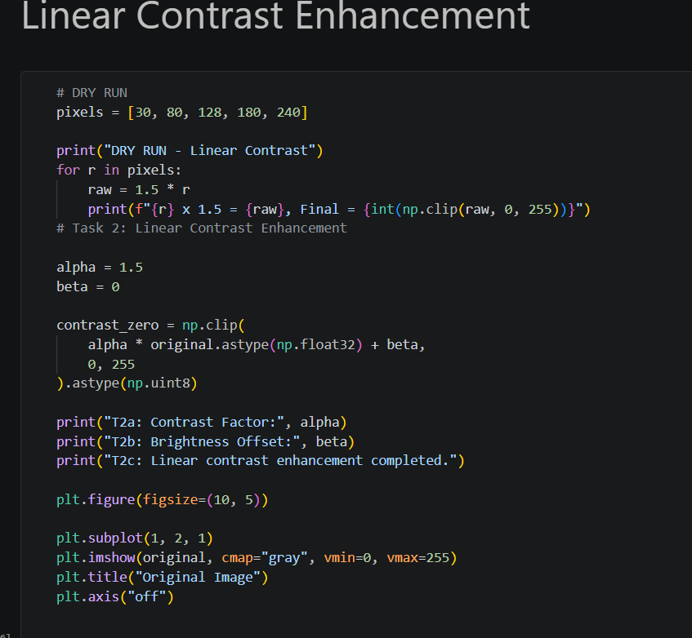

Result: The contrast of the grayscale image was increased to observe how intensity scaling affects image appearance.
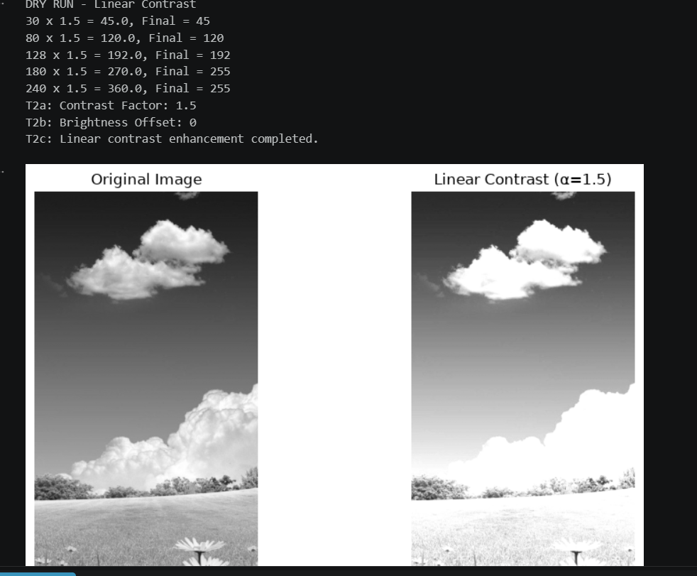

8. Practical 3: Centered Contrast Adjustment

- Centered contrast adjustment changes the contrast of an image while considering the midpoint intensity value.
- In this method, the midpoint value of 128 was used as a reference. Pixel values were adjusted according to their distance from this midpoint.
- A contrast factor greater than 1 increased the difference between pixel intensities and the midpoint. A factor less than 1 reduced this difference.
- Two contrast settings were applied to observe the effects of increasing and decreasing contrast.

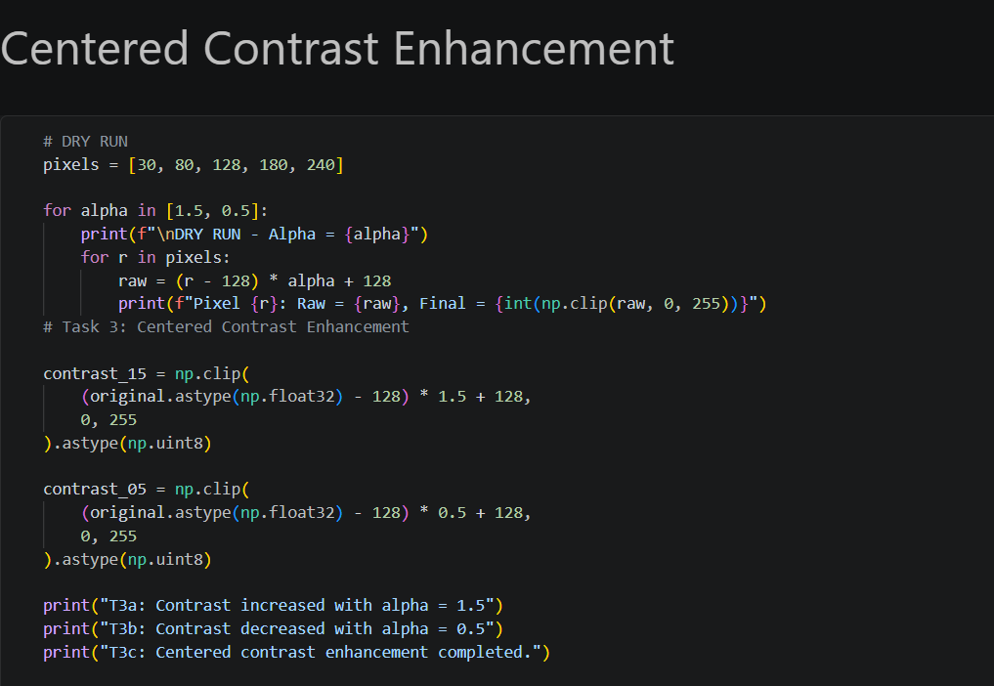
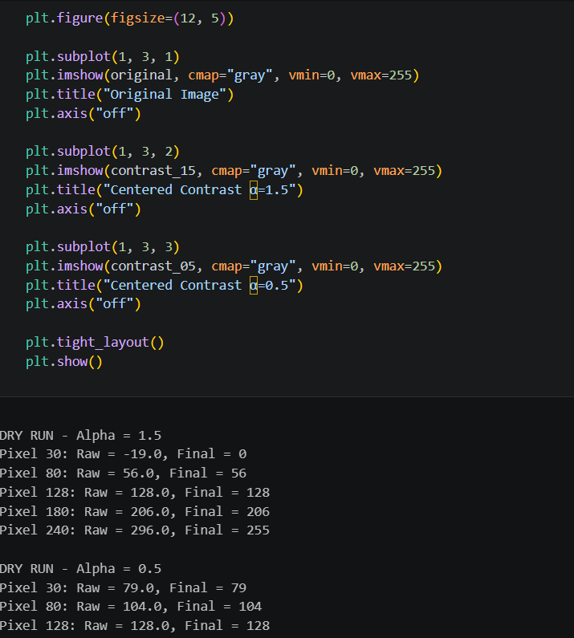
Result: Two images were produced, showing higher contrast and lower contrast compared with the original grayscale image.
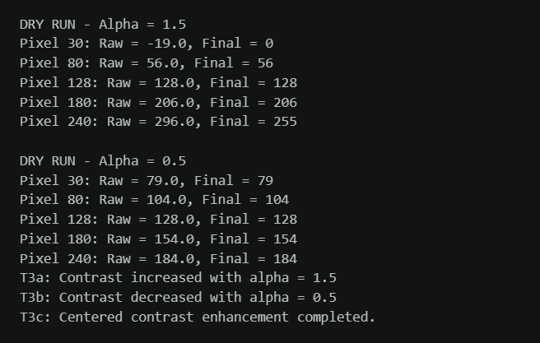
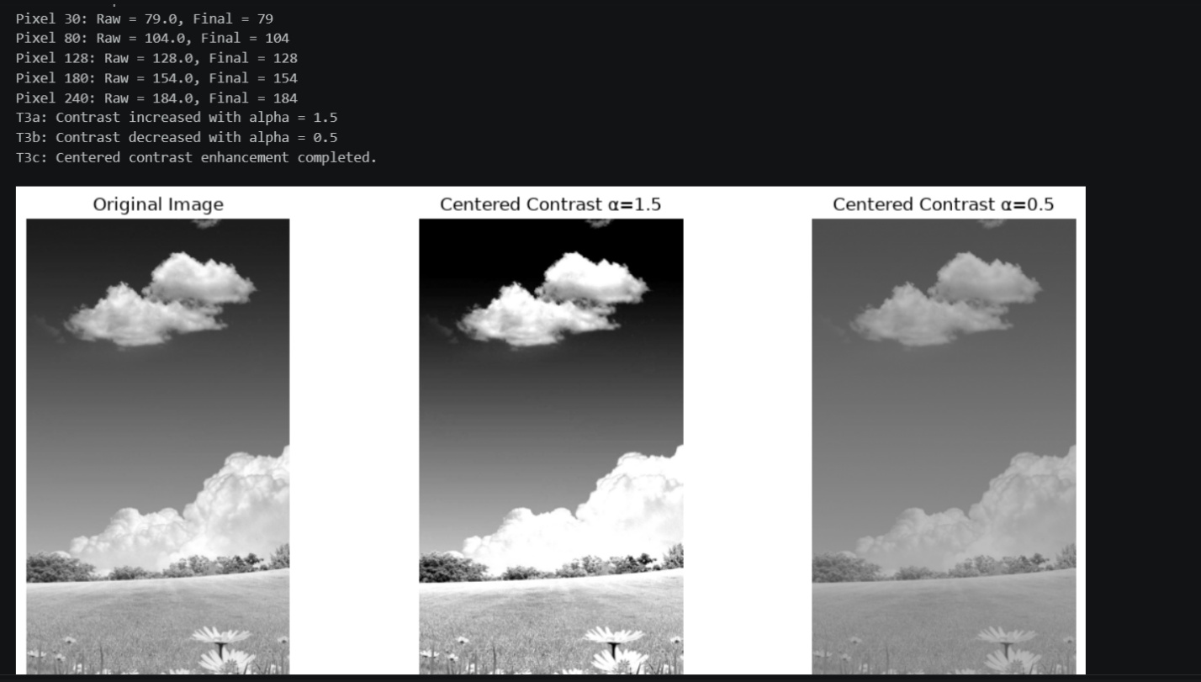

9. Practical 4: Image Negative

- Image negative is an intensity transformation in which the brightness values of pixels are reversed.
- In an 8-bit grayscale image, the negative intensity is calculated by subtracting the original pixel intensity from 255.
- As a result, dark regions become bright, while bright regions become dark. This operation produces an image with reversed intensity levels.
- The negative operation was also applied twice to observe its effect. Applying the negative transformation a second time restores the original grayscale intensity values.
- 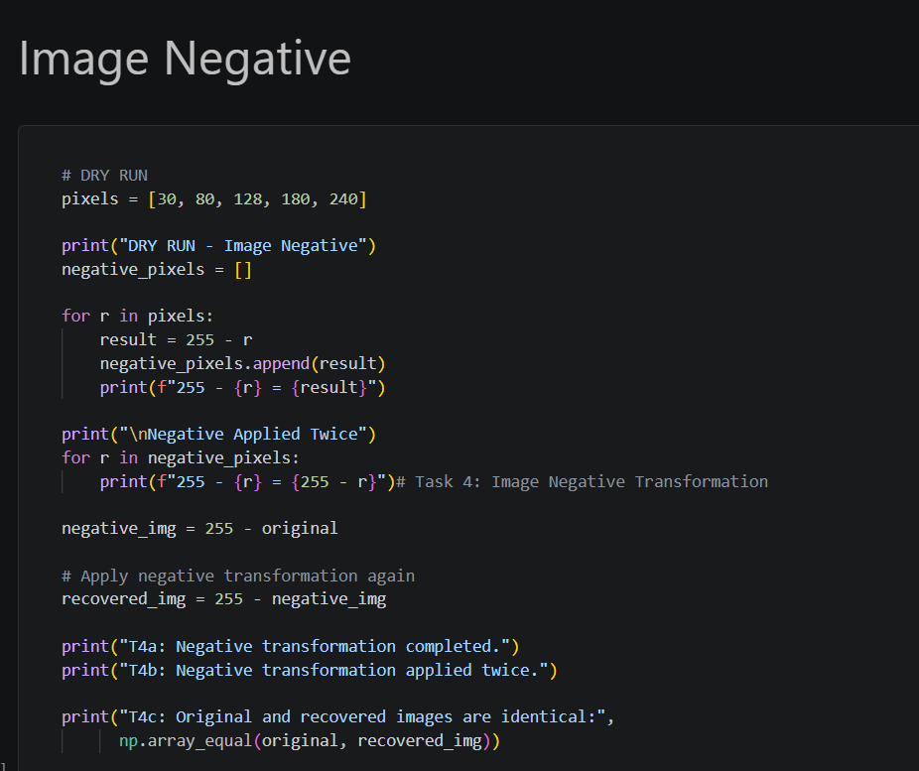
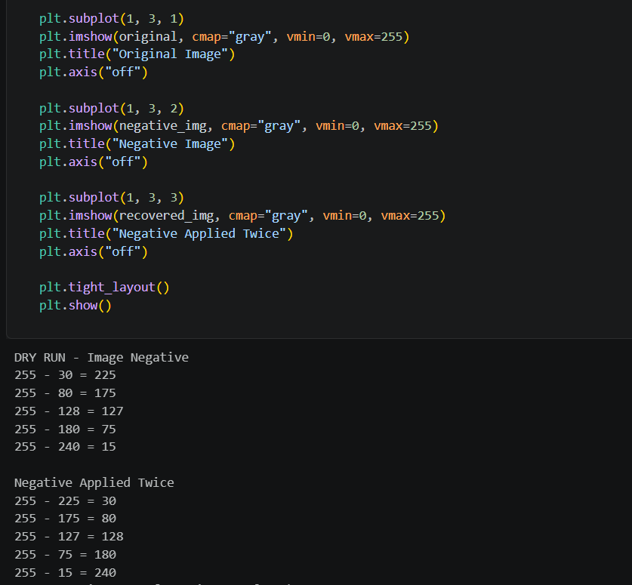

Result: A negative image was generated, and the double-negative operation demonstrated that applying the transformation twice returns the original image.
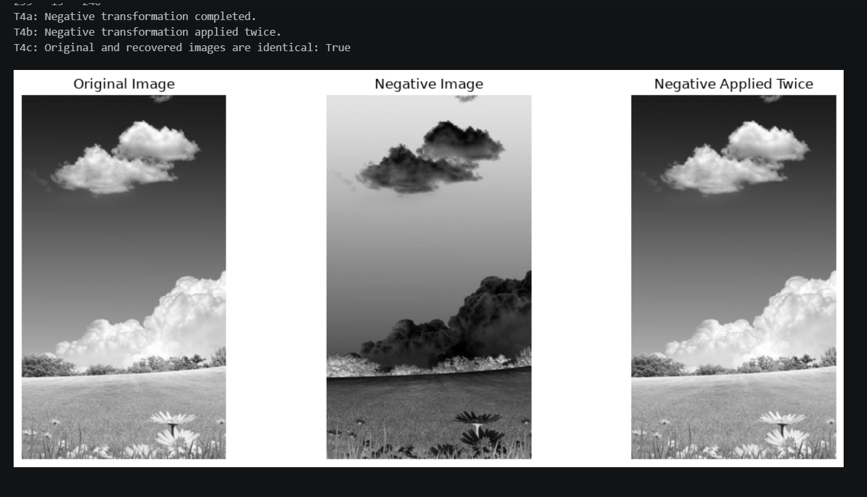

10. Practical 5: Gamma Correction

- Gamma correction is a nonlinear intensity transformation used to control the brightness appearance of an image.
- It adjusts pixel intensity values using a power-law relationship. Before applying the transformation, intensity values are normalized to the range of 0 to 1. After the transformation, they are converted back to the range of 0 to 255.
- A gamma value less than 1 generally makes the image brighter. A gamma value greater than 1 generally makes the image darker.
- In this practical, two gamma values were applied to compare their effects on the grayscale image.
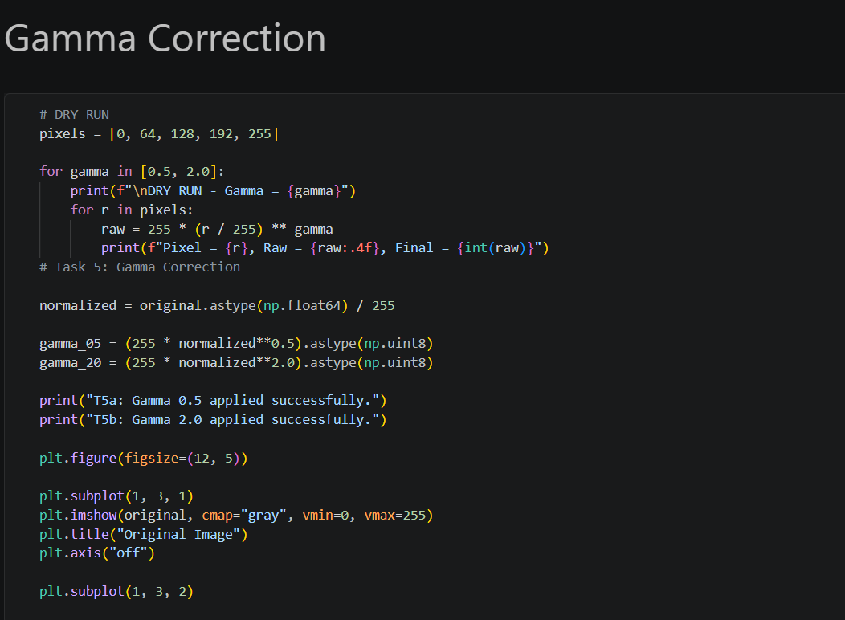
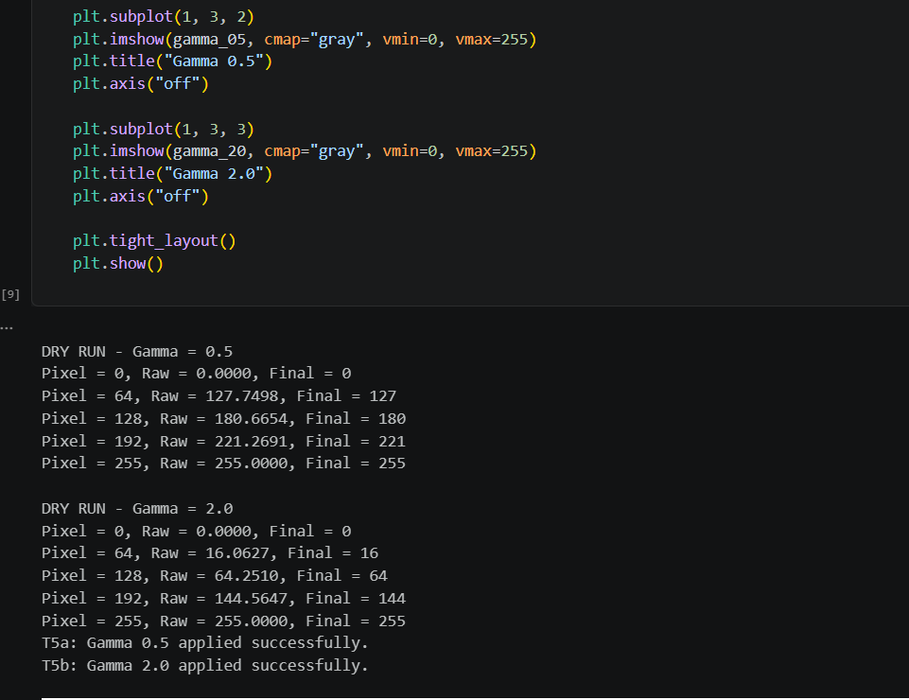
Result: Two gamma-corrected images were obtained, demonstrating how different gamma values affect image brightness and intensity distribution.
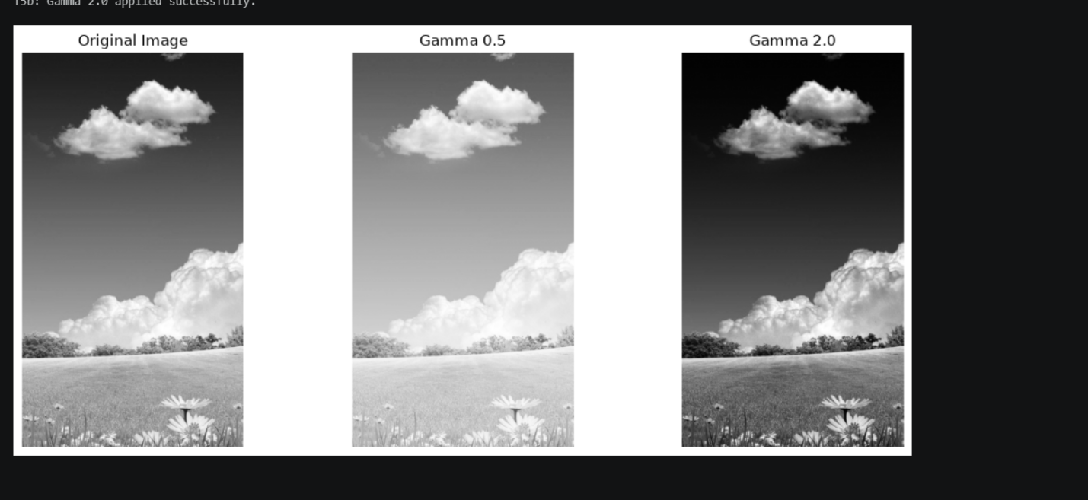

11. Practical 6: Image Histogram

- An image histogram is a graphical representation of the distribution of pixel intensity values in an image.
- For an 8-bit grayscale image, the histogram contains 256 possible intensity levels, ranging from 0 to 255.
- The horizontal axis represents the intensity values, while the vertical axis represents the number of pixels having each intensity value.
- Histograms help us understand the brightness and contrast characteristics of an image. A histogram concentrated toward the left indicates more dark pixels, while a histogram concentrated toward the right indicates more bright pixels.
- In this practical, a histogram was calculated to examine the distribution of grayscale intensity values.
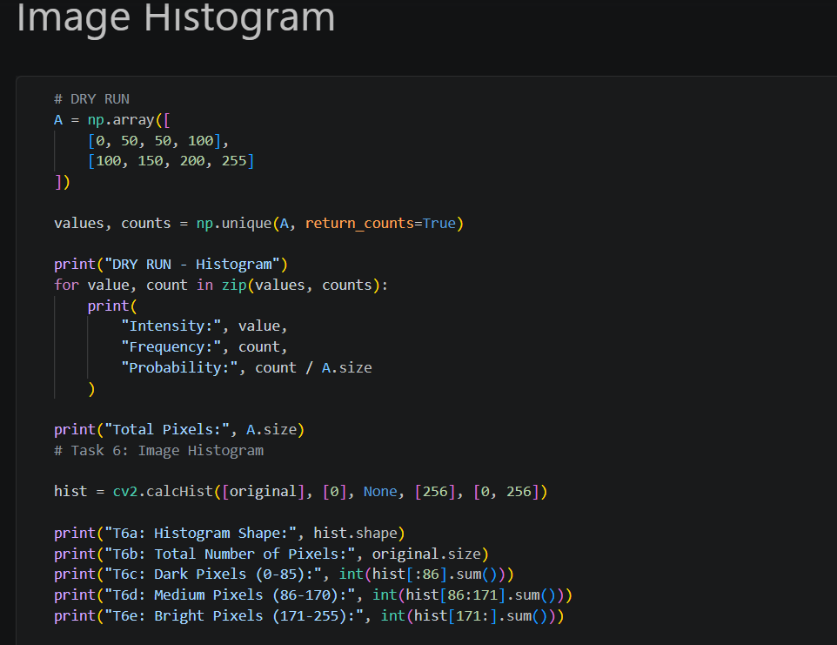
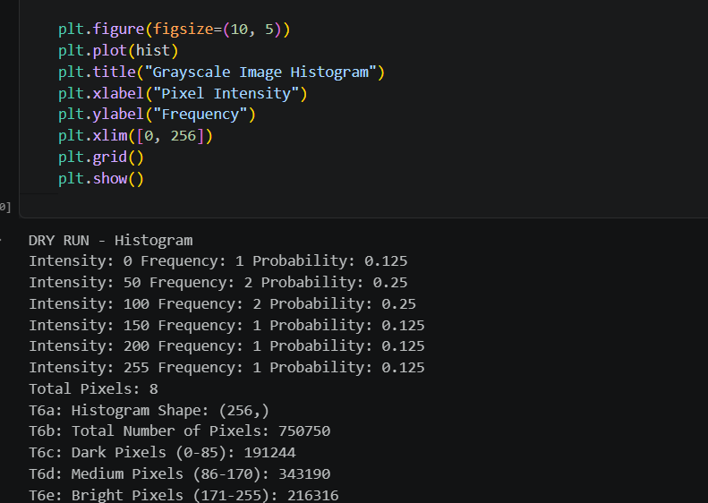
Result: The histogram provided information about the intensity distribution of the image.
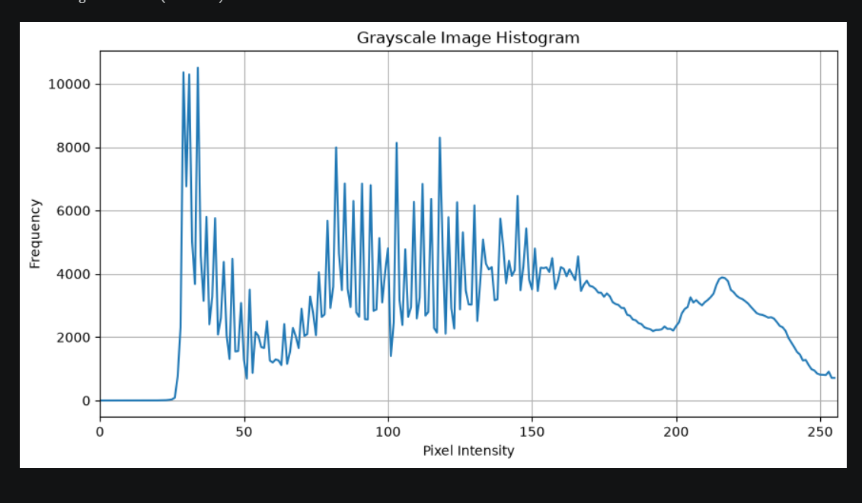

12. Practical 7: Histogram Equalization

- Histogram equalization is an image enhancement technique used to improve contrast by redistributing pixel intensity values.
- It works by using the cumulative distribution of the image histogram to map the original intensity values into a new intensity range.
- This process can make details more visible, especially when the original image has low contrast or its intensity values are concentrated within a limited range.
- In this practical, histogram equalization was applied to the grayscale image using OpenCV.

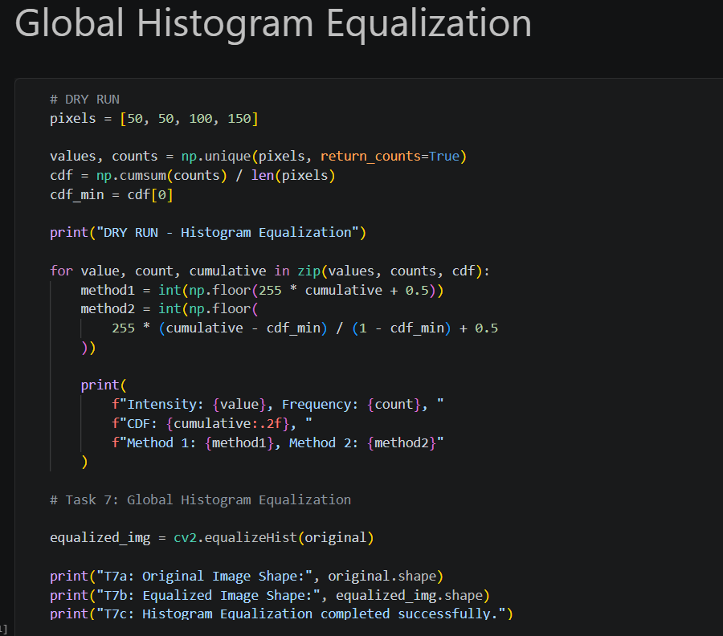
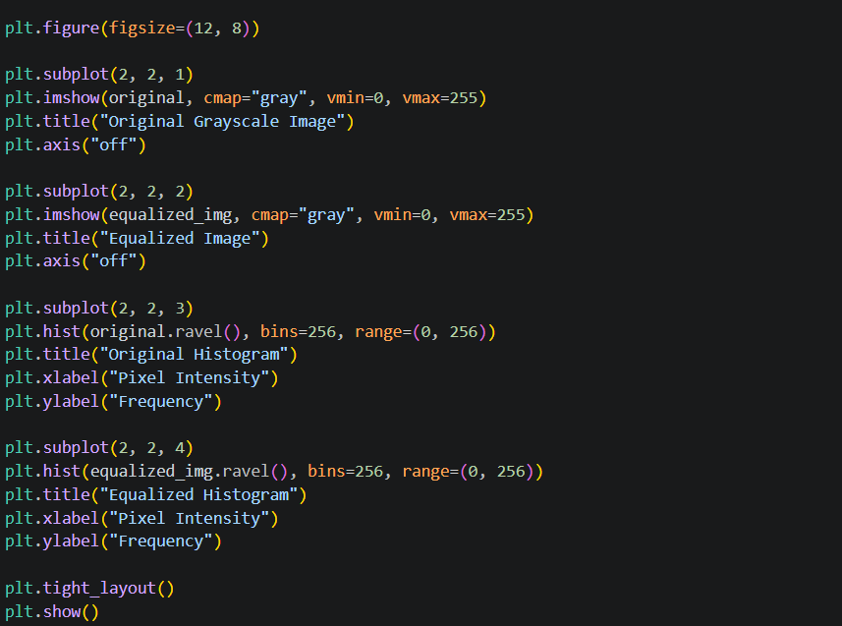
Result: An equalized image was produced to demonstrate how redistributing intensity values can improve image contrast.

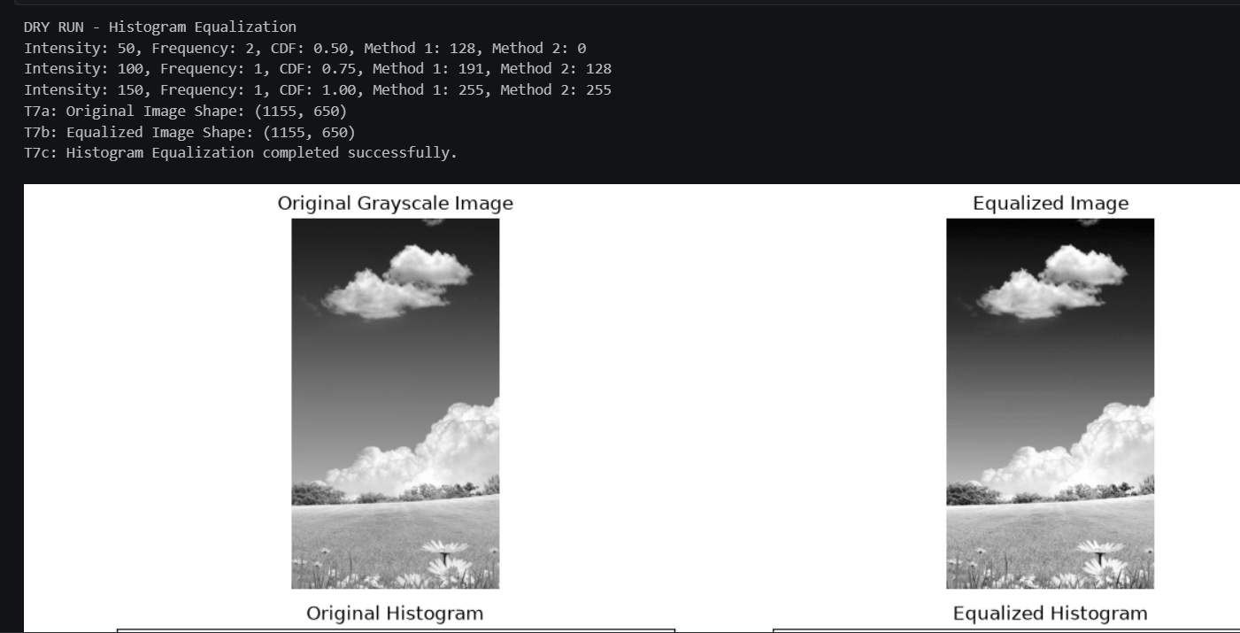
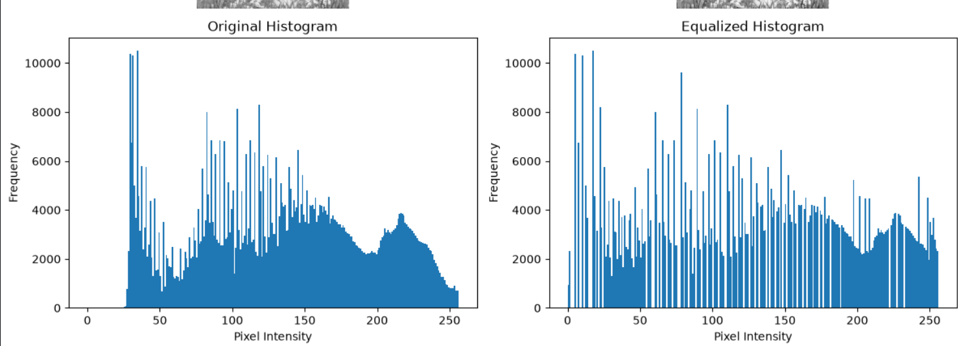
13. Practical 8: CLAHE (Contrast Limited Adaptive Histogram Equalization)

- CLAHE stands for Contrast Limited Adaptive Histogram Equalization. It is an image enhancement technique that improves contrast locally rather than applying the same histogram transformation to the entire image.
- Unlike ordinary histogram equalization, CLAHE divides the image into smaller regions called tiles. Histogram equalization is then performed separately in these regions.
- The contrast enhancement is limited to prevent excessive amplification of noise. The neighbouring regions are combined smoothly to avoid visible boundaries between tiles.
- In this practical, CLAHE was applied to the grayscale image using OpenCV.
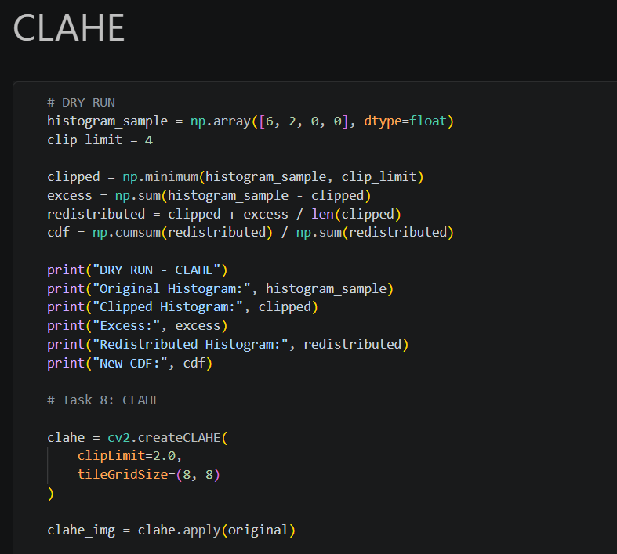
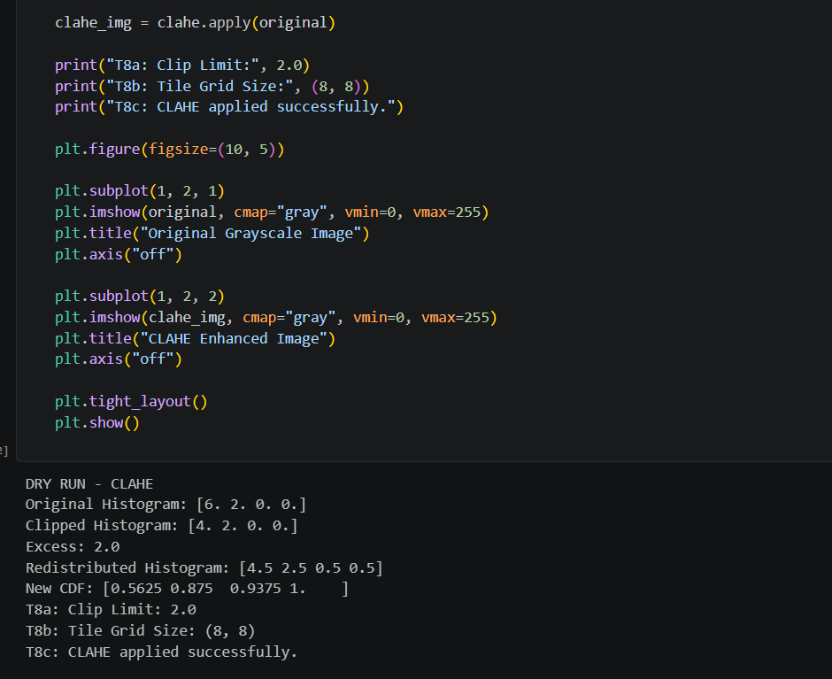
Result: A CLAHE-enhanced image was generated to demonstrate local contrast enhancement while limiting excessive contrast amplification.
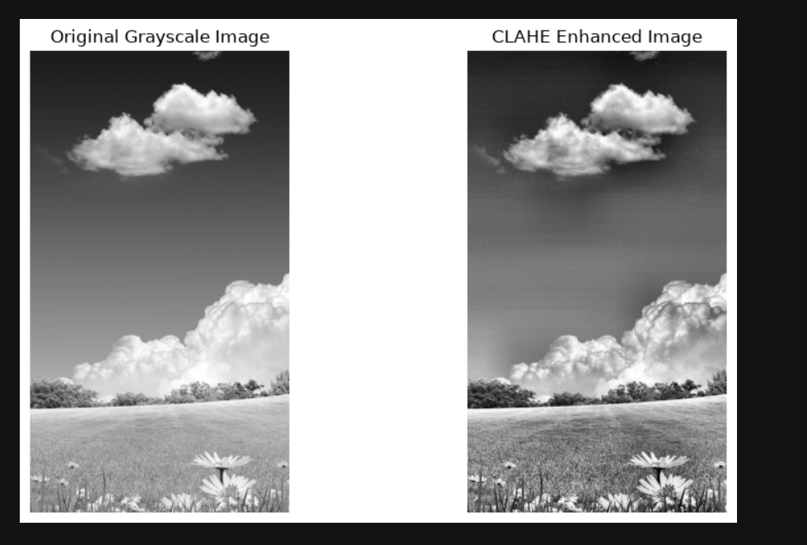

14. Practical 9: Fixed Thresholding

- Thresholding is a technique used to convert a grayscale image into a binary image.
- In fixed thresholding, a threshold value is selected in advance. Each pixel is compared with this value.
- Pixels greater than the selected threshold are assigned a value of 255 (white), while pixels less than or equal to the threshold are assigned a value of 0 (black).
- In this practical, two different threshold values were used to observe how changing the threshold affects the resulting binary image.
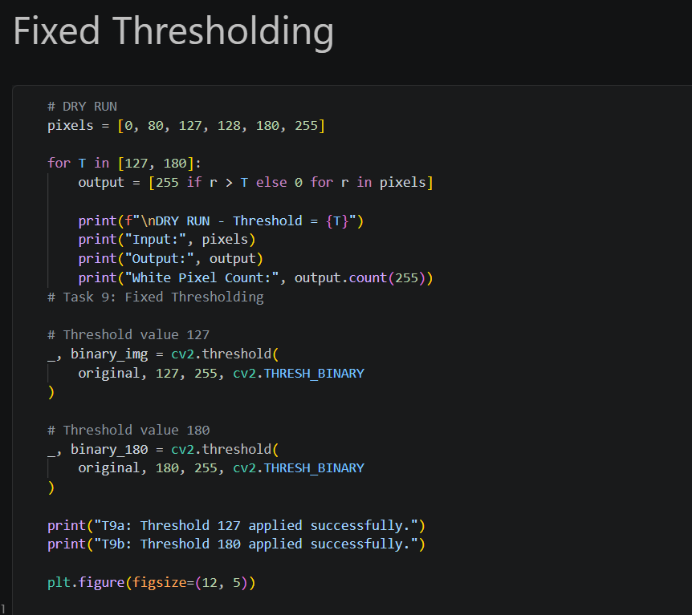
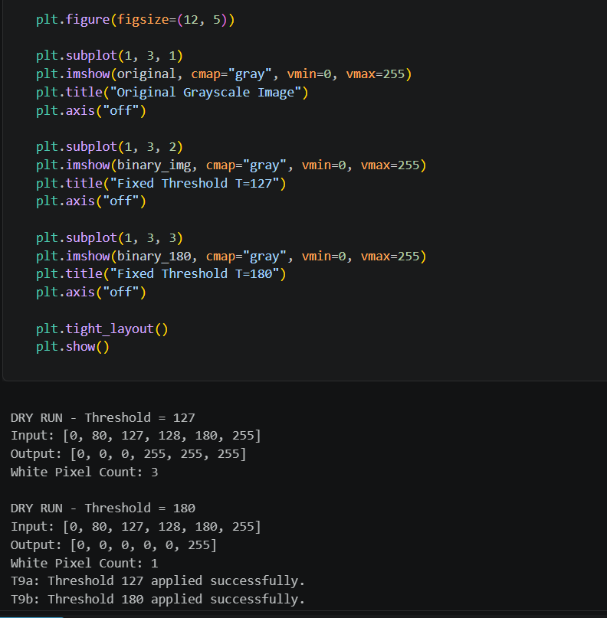

Result: Two binary images were generated using different fixed threshold values.
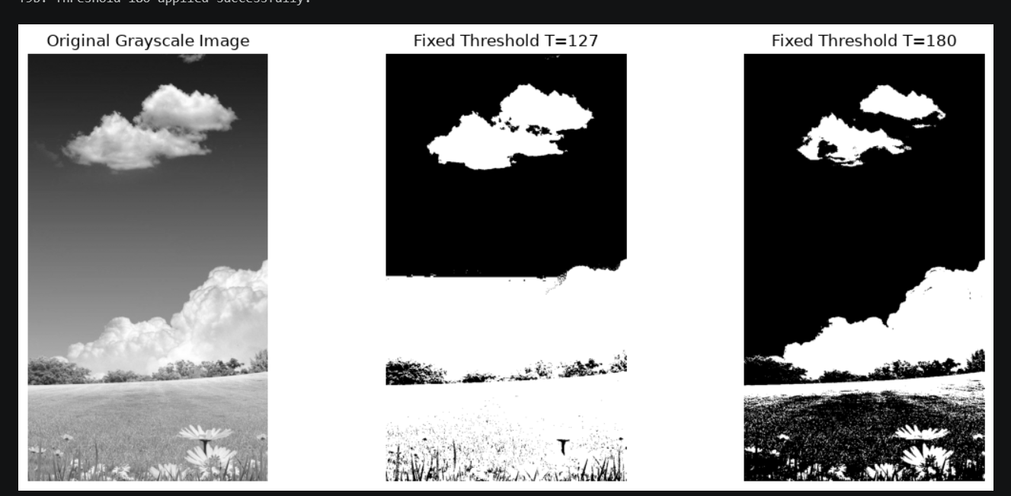

15. Practical 10: Otsu's Thresholding

- Otsu's thresholding is an automatic threshold-selection technique used to separate an image into foreground and background regions.
- Instead of requiring the user to manually select a threshold value, Otsu's method calculates a suitable threshold from the image histogram.
- It selects the threshold that maximizes the separation between the two intensity classes, commonly described as maximizing between-class variance.
- In this practical, Otsu's thresholding was applied using OpenCV. The automatically selected threshold value was obtained along with the binary image.

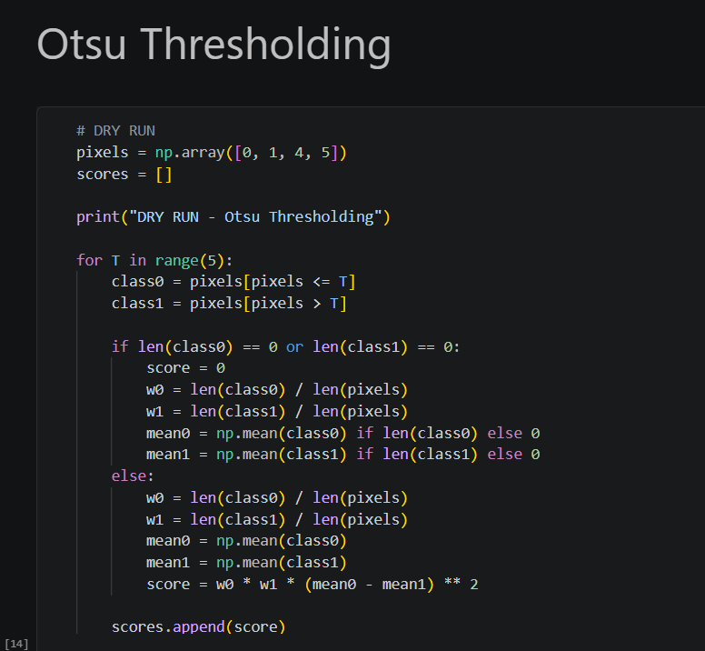
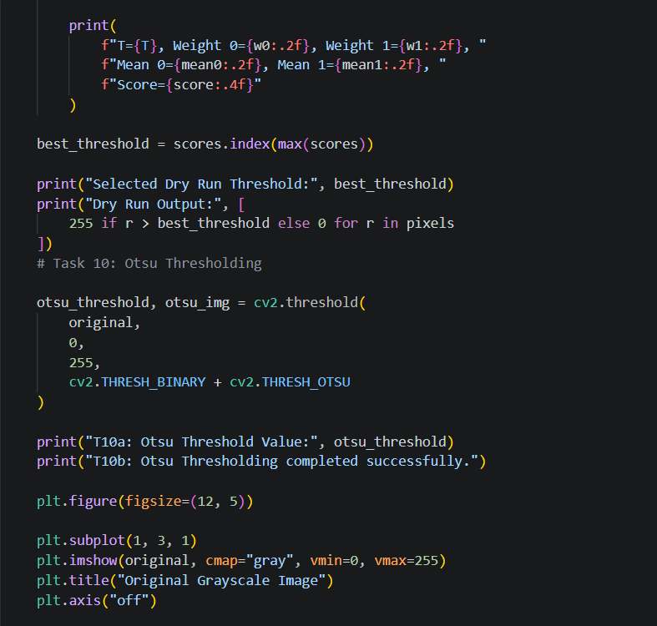
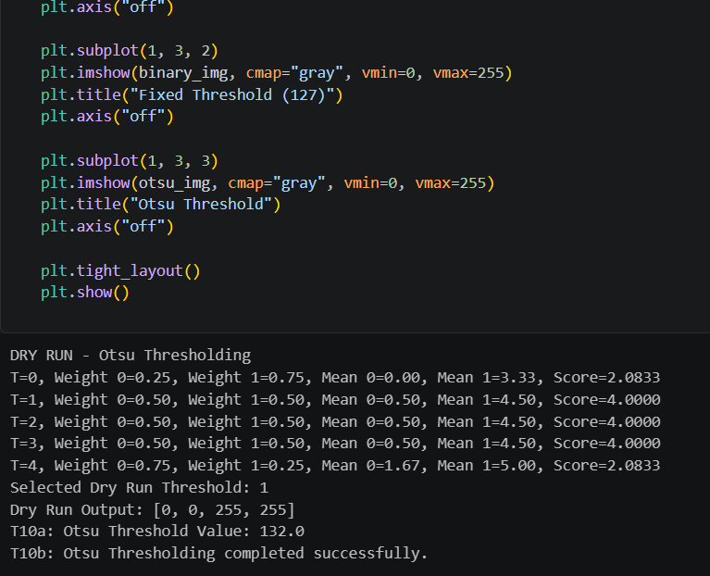
Result: A binary image was generated using an automatically calculated threshold value.
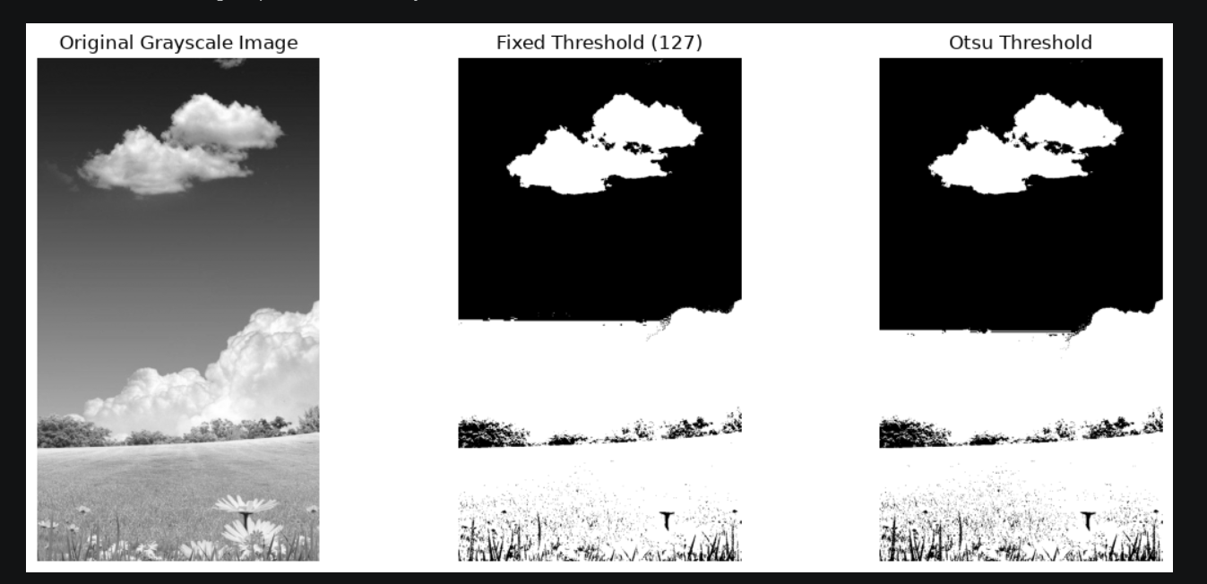

16. Practical 11: Adaptive Thresholding

- Adaptive thresholding is a technique in which the threshold value is calculated separately for different regions of an image.
- Unlike fixed thresholding, which uses one threshold for the entire image, adaptive thresholding considers the local neighbourhood around each pixel.
- In this practical, adaptive Gaussian thresholding was applied. This method calculates a local threshold using a weighted average of neighbouring pixel intensities, with greater importance given to pixels closer to the center.
- A constant value is subtracted from the calculated local average to determine the threshold.
- Adaptive thresholding is useful when an image contains different lighting conditions or uneven illumination.
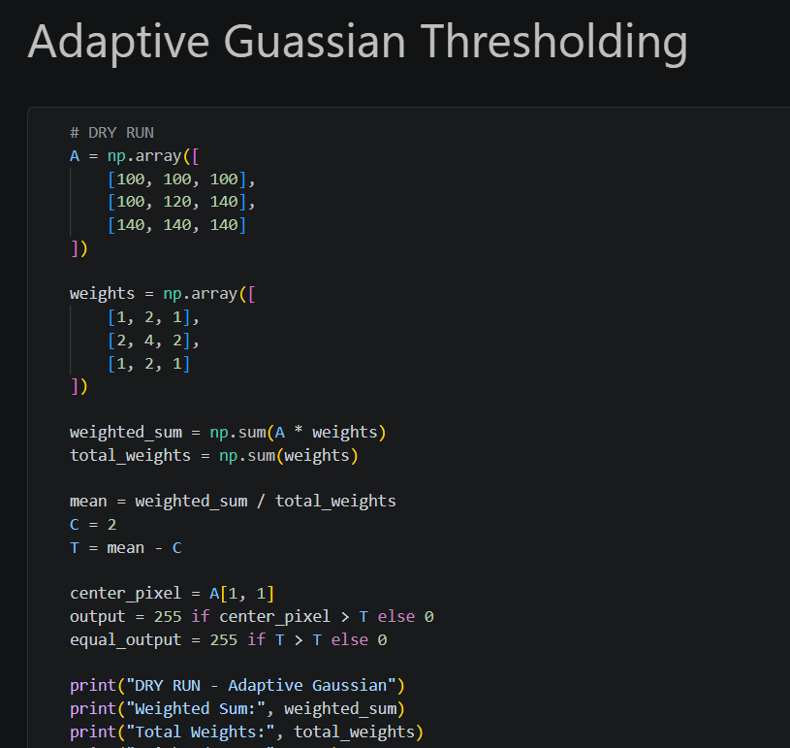
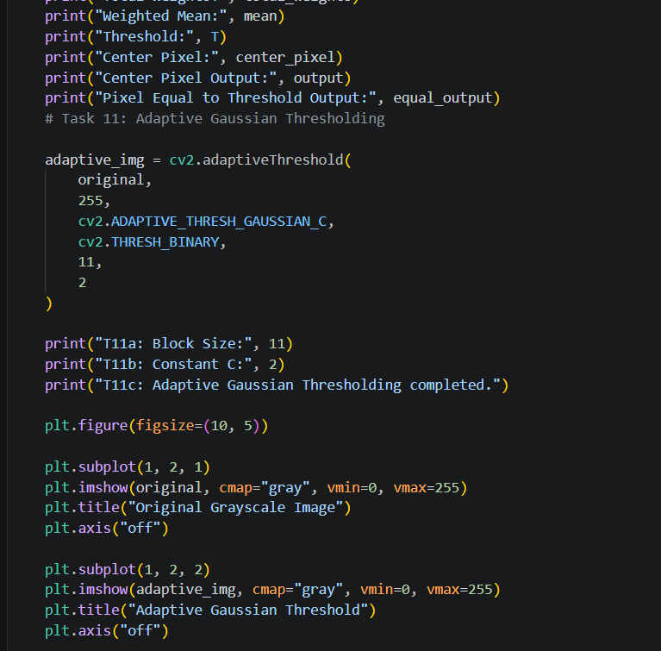
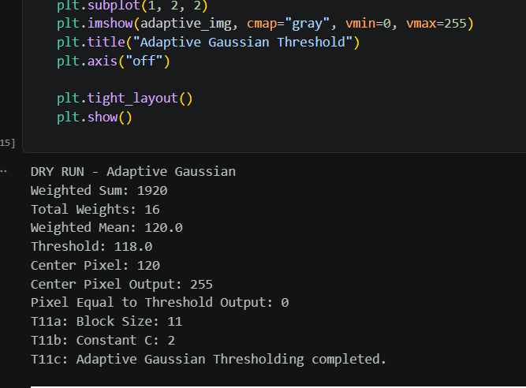

Result: A binary image was produced using locally calculated threshold values.
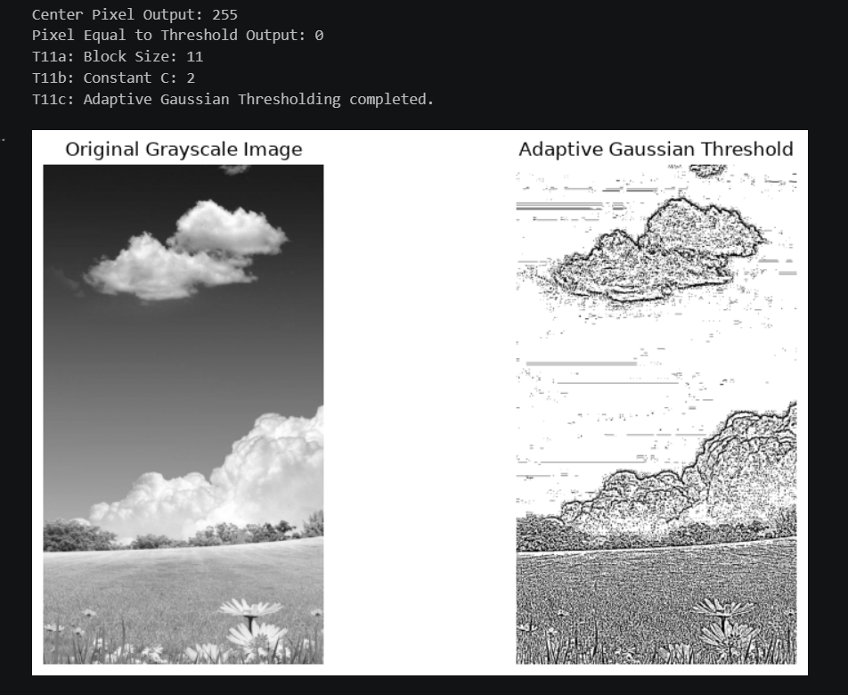

17. Saving the Processed Images

- After completing all image-processing operations, the generated images were saved in a separate folder named Processed_Images.
- The final saving process included the original color image, the grayscale image, and the processed images obtained from the practicals.
- Each image was saved with a suitable filename in PNG format. This made it easier to identify, organize, compare, and use the results later.
- The original and processed images were kept separate so that the effects of each image-processing technique could be examined.
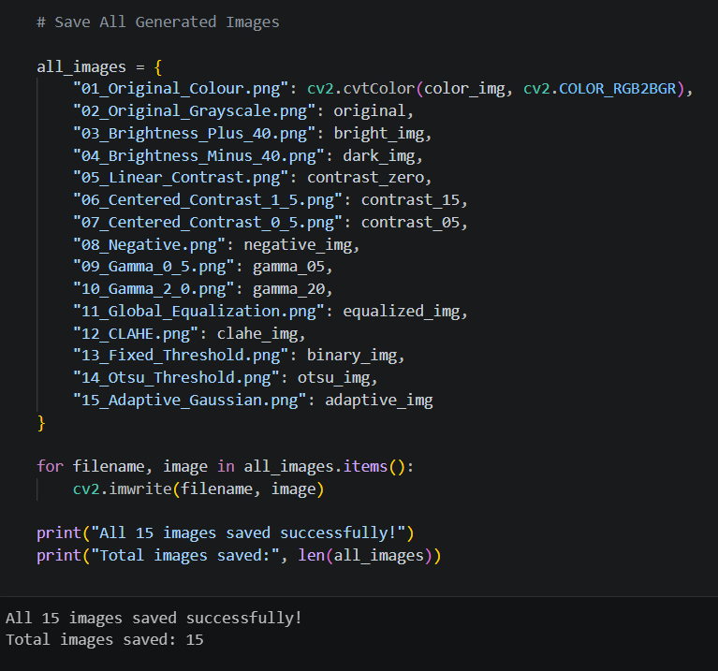

18. Overall Results and Discussion

- All the practicals demonstrated different methods of modifying and analyzing digital images.
- Brightness adjustment changed the overall lightness and darkness of the image. Contrast adjustment changed the difference between intensity levels. The negative transformation reversed pixel intensities, while gamma correction demonstrated nonlinear brightness adjustment.

- Histogram analysis provided information about the distribution of pixel intensities. Histogram equalization improved global contrast, while CLAHE performed local contrast enhancement with limitations on contrast amplification.
- Fixed thresholding used manually selected intensity values to create binary images. Otsu's method automatically selected a threshold, while adaptive thresholding calculated local threshold values based on neighbouring pixels.
- The results showed that different image-processing techniques are useful for different purposes. The choice of technique depends on the characteristics of the original image and the desired output.

19. Conclusion

In this laboratory task, different fundamental digital image-processing techniques were successfully studied and implemented using Python and OpenCV.

The work started with loading and displaying the original color image, followed by converting it into grayscale. The grayscale image was then used as the input for brightness adjustment, contrast enhancement, image negative, gamma correction, histogram analysis, histogram equalization, CLAHE, fixed thresholding, Otsu's thresholding, and adaptive thresholding.

The practicals helped develop an understanding of how pixel intensity values can be modified and how different techniques affect image appearance and contrast.

Finally, the original color image, grayscale image, and processed images were saved in a separate folder for future reference and comparison.

Overall, this lab task provided practical experience with basic digital image-processing operations and demonstrated the importance of image enhancement and thresholding techniques.

